- Using Synchronization
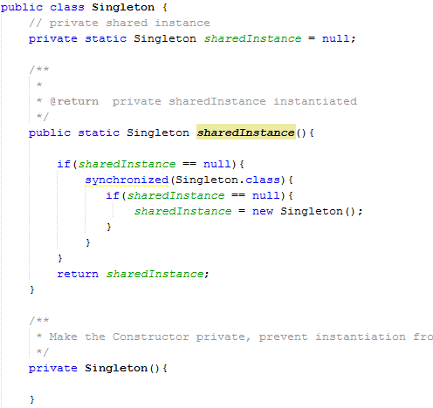

- We use Synchronization to guarantee that only one thread can access the instantiation code block at the same time.
- We know that using Synchronization is expensive, so we need to find a better way to reduce Synchronization overhead. Here, we added one more If condition to check the shared instance. So the Synchronization overhead is applicable for first few threads when the shared instance is NULL.

- Using Inner class
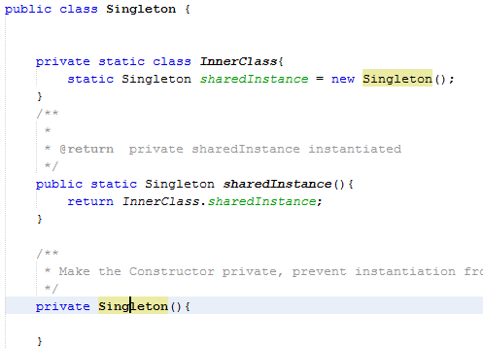

When we get shared instance from static method, JVM load the inner class, and it's 100% thread safe

